

REQUEST FOR EXTENSION OF MAXIMUM RESIDENCY RULE (CSAPG LEVEL)

Date: _________________________

DR. MARIA VANESSA LUSUNG-OYZON
Chair, UC CSAPG

Subject: Letter of Appeal: CSAPG (Committee on Student Admissions, Progress, and Graduation)
Thru Channels:
Dear Dr. Maria Vanessa Lusung-Oyzon,

I would like to request for the extension of the maximum residency rule for the following reasons:
____________________________________________________________________________________________________________________________________________________________________________________
Start of Extension Period: ____________, with the extension valid up to: ______________

Please find attached my Gantt Chart endorsed by the thesis/dissertation adviser. I hope my request will merit your kind consideration. Thank you.

_____________________________ _____________________________ _____________________________
Signature over Printed Name Degree Program Student Number

Endorsed by: Recommending Approval:

_________________________________ _______________________________
Program Adviser Director / Program Coordinator

Recommending Approval: Approved:

_________________________________ _______________________________ Manuel Joseph C. Loquias, Dr. math. Cynthia P. Saloma, Ph.D.
Associate Dean for Academic Affairs Dean, College of Science

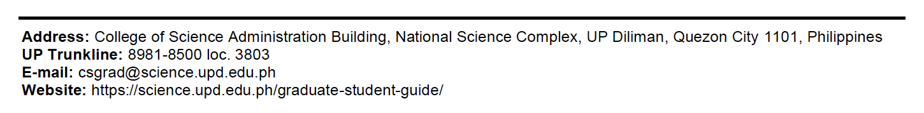
*Based on the action/s of the abovementioned College/Institute/School officials, the appeal can be endorsed by the University Registrar, if necessary. Attach the following: TCG, Program of Study, Thesis/Dissertation Proposal, Result of Preliminary/Comprehensive/ Qualifying/ Candidacy Examinations, Colloquium. These are the usual documents being required by the Committee. The Committee may request additional supporting documents. You may also decide to include any other documents you feel may be helpful. Use this form if the MRR is more than 10 years for MS and PhD by Research, more than 11 years for PhD, more than 13 years for Straight PhD.

