

REQUEST FOR EXTENSION OF MAXIMUM RESIDENCY RULE (COLLEGE LEVEL)

Date: _________________________

DR. CYNTHIA P. SALOMA
Dean, College of Science

Dear Dr. Saloma,

I would like to request for the extension of the maximum residency rule for the following reasons:
____________________________________________________________________________________________________________________________________________________________________________________
Below are some details for your information:

Term of Initial enrollment (Start of Graduate Subject/s Enrolled): ______________________

Term of Maximum Residence Rule (5 yrs for MS; 6 yrs for PhD; 8 yrs for Straight PhD)

Start of Extension Period: ____________, with the extension valid up to: ______________ (Maximum Residency Rule suspended for the following semesters: 2nd sem 2019-2020, 1st and 2nd sem 2020-2021, and 1st and 2nd sem 2021-2022 due to pandemic)
This request is for my ( ) 1st ( ) 2nd ( ) 3rd ( ) 4th ( ) 5th extension, ( ) without ( ) with ___ units of additional course work.

Please find attached my Gantt Chart endorsed by the thesis/dissertation adviser. I hope my request will merit your kind consideration. Thank you.

_____________________________ _____________________________ _____________________________
Signature over Printed Name Degree Program Student Number

Endorsed by: Recommending Approval:

_________________________________ _______________________________
Program Adviser Director / Program Coordinator

Recommending Approval: Approved:

_________________________________ _______________________________ Manuel Joseph C. Loquias, Dr. math. Cynthia P. Saloma, Ph.D.
Associate Dean for Academic Affairs Dean, College of Science

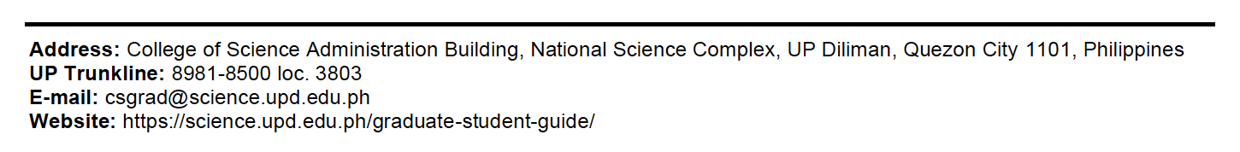
* Request for MRR extension is every Academic Year; 3 units of penalty subject should be enrolled within two (2) years. If the student is due to graduate within the first semester of the MRR period, said student should enroll the penalty subject during that semester (based on the CS Guidelines; refer to the following website www.science.upd.edu.ph)

